**KWAME NKRUMAH UNIVERSITY OF SCIENCE AND TECHNOLOGY**

**COLLEGE OF SCIENCE**

**COMPUTER SCIENCE DEPARTMENT**



**CAFÉ SITE**

**A PROJECT REPORT**

**Submitted by**

**Cyril Kwasi Addae Bediako**

**5310820**

**TABLE OF CONTENT**

ABSTRACT…………………………………………………………………………………2

INTRODUCTION…………………………………………………………………………,.3

PROBLEM STATEMENT.......…………………………………………………………….4

OBEJECTIVES……………………………………………………………………………..4

FEATURES…………………………………………………………………………………5

IMPLEMENTATION(METHODOLOGY)………………………………………………..6

CONCLUSION…………………………………………………………………………….8

# ABSTRACT

The Coffee Shop Locator App is a new digital tool that makes it easier for people to find and enjoy coffee shops. It's especially useful in busy cities where there are lots of coffee places to choose from. This app uses GPS technology, user reviews, and personalized recommendations to help you find the perfect coffee spot.

With this app, you can easily see all the coffee shops near you on a map. You can learn about what each place offers, what it's like inside, and read what other people think about it. The app also gives you suggestions based on what you like and what you've tried before, so you can have a unique coffee experience every time.

For coffee shop owners, this app is a great way to show off their special drinks and connect with more customers. They can also create loyalty programs to keep their regulars coming back. People can share their thoughts and ratings about the coffee shops they visit, creating a fun coffee-loving community.

The Coffee Shop Locator App brings together technology and the love of coffee. It makes finding a great coffee shop easy and fun, turning each visit into an adventure and every coffee shop into a special place to explore.

## INTRODUCTION

## In today's fast-paced world, finding coffee shops that match your preferences has become really important. People have different ways of doing this, like asking for recommendations or searching online. But, some folks are now using coffee shop locator apps, which make this process much easier.

## These apps are designed to give you real-time information about nearby coffee shops. They're like digital maps that help you find coffee places quickly and easily. They use technology to show you options based on where you are or where you want to go.

## Just like how we use technology for things like facial recognition for attendance, these coffee shop locator apps have also gotten smarter. They don't just show you coffee shop names and locations; they can also give you suggestions based on your tastes, show you reviews from other customers. These apps are a blend of convenience and innovation, using the latest in mobile and location technology.

## This particular coffee shop locator app is all about making your search for the perfect coffee spot simpler. It gives you accurate and up-to-date information and helps you choose places that match your coffee preferences. In a world where time and convenience are important, these apps are like a helpful tool for coffee lovers looking for their favorite cup of coffee.

## PROBLEM STATEMENT

## In busy cities, there are lots of coffee shops, and it can be tough to find the one you like. People usually rely on old-fashioned ways to find them, like searching for hours or trying different places until they find a good one. But as coffee culture grows, there's a need for a better way to find coffee shops.

## The problem is that there's no easy and up-to-date way to find nearby coffee shops and see what they're like. This makes it hard for coffee lovers to discover new places and for coffee shop owners to show off their unique offerings.

## People now want an app that uses technology to solve this problem. They want an app that tells them where the closest coffee shops are, what they serve, what the place is like, and what other customers think. Coffee shop owners also want this app to connect with their customers and promote their businesses.

## So, we need to create a smart coffee shop locator app that uses technology to give people all the information they need to find the perfect coffee spot. This app should help both coffee lovers and coffee shop owners in a win-win way.

## OBJECTIVES

1. Efficient Exploration: Develop a user-friendly and intuitive app that allows users to easily explore and discover a wide range of coffee shops in their vicinity or at specified locations.

2. Real-time Information: Provide up-to-date and accurate information about coffee shop locations, operating hours, menu offerings, and special promotions to ensure users make informed decisions.

3. Personalized Recommendations: Implement a recommendation system that takes into account users' preferences, previous choices, and behavior to suggest coffee shops that align with their taste and preferences.

4. Interactive Mapping: Integrate interactive mapping features to help users navigate to their chosen coffee shops with ease, providing step-by-step directions and estimated travel times.

## 

## FEATURES

* Allow site visitors to view coffee shops

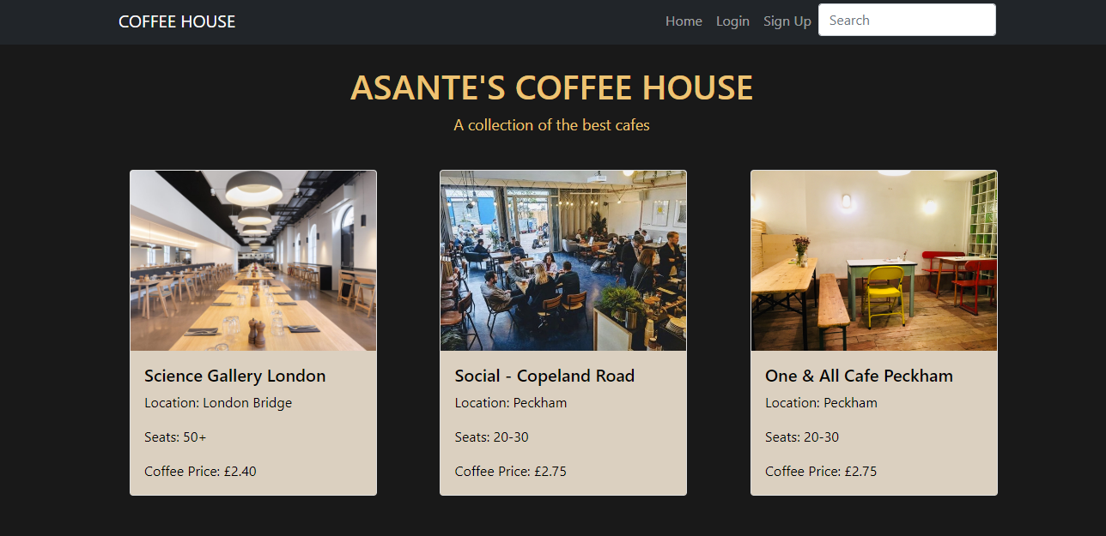

* Provides google map to help visitors locate shop

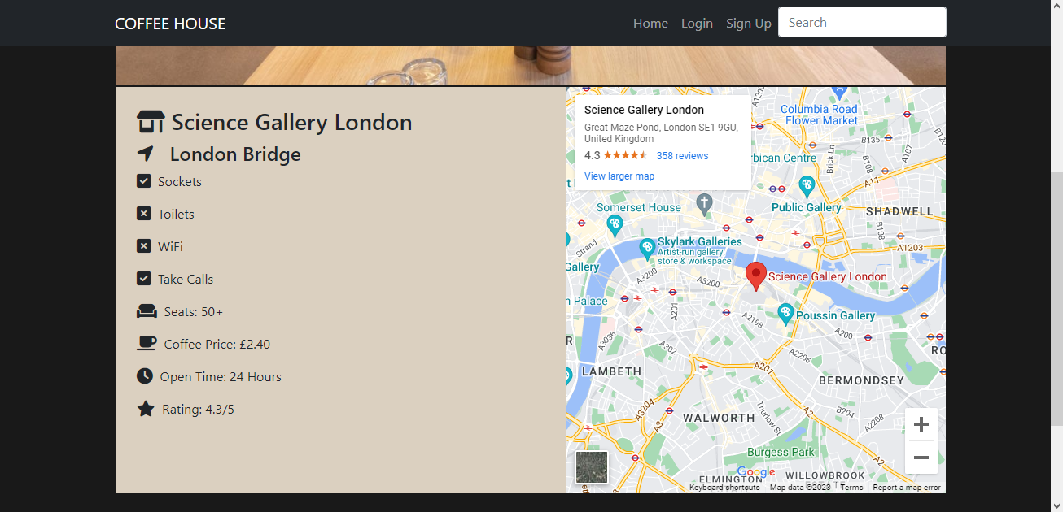

## IMPLEMENTATION (METHODLOGY)

This section outlines the methodology for the development of a coffee shop locator app, encompassing the various stages from conceptualization to implementation.

1. Requirement Analysis:

- Conduct user surveys and interviews to understand user preferences, pain points, and expectations from a coffee shop locator app.

- Establish the technical requirements, including mobile platforms (iOS, Android), database systems, mapping APIs (Google Maps), and backend technologies.

2. Conceptual Design:

- Create wireframes and prototypes of the app's user interface (UI) to visualize the app's layout, navigation, and user interactions.

- Design the app's color scheme, typography, and visual elements to ensure a cohesive and appealing user experience.

3. Database Design:

- Design a database schema to store coffee shop information, including location coordinates, menu items, and user reviews.

- Integrate the chosen database system (SQLite) to efficiently store and retrieve data.

4. Development:

- Implement the frontend of the app using appropriate programming languages (HTML, CSS, and JS), ensuring responsiveness across various device sizes.

- Integrate geolocation services to provide accurate location tracking and mapping functionalities.

- Develop algorithms for personalized recommendations based on user preferences and historical behavior.

- Implement user authentication and authorization mechanisms to ensure secure access to user-specific features.

5. Backend Development:

- Set up the backend server using relevant technologies (Flask, SQLAlchemy) to handle data processing, user authentication, and communication with the database.

- Develop APIs to support frontend functionalities, including fetching coffee shop data, submitting reviews, and processing loyalty rewards.

6. User Testing:

- Conduct usability testing with a sample of potential users to identify any usability issues, navigation challenges, or technical glitches.

- Gather feedback on the app's features, design, and overall user experience.

7. Refinement:

- Based on user feedback, refine the app's UI/UX, fix any identified bugs, and optimize performance.

- Fine-tune the recommendation algorithms to improve the accuracy of personalized suggestions.

8. Deployment:

- Deploy the app on the internet after ensuring compliance with their guidelines and policies.

- Monitor the app's performance and user feedback post-launch, making necessary updates and improvements based on user responses.

9. Maintenance and Updates:

- Continuously monitor the app's performance, address any newly identified issues, and release regular updates to introduce new features and enhancements.

- Stay updated with emerging technologies and trends to ensure the app remains competitive and relevant in the market.

## 

## CONCLUSION

In today's world, where people want things to be easy, tailored to their tastes, and love to explore, the coffee shop locator app is a big deal. This app has the potential to change how coffee lovers find and enjoy coffee shops in busy cities.

The app is important because it solves the problem of too many coffee shops and not knowing where to go. It does this by using technology to show you where the coffee shops are, what they offer, what others say about them, and even gives you recommendations based on your likes. It's like a one-stop-shop for all things coffee.

Like any technology, this app will get even better in the future. It might add cool things like using your phone's camera to show you coffee shops around you or use new tech to give you even better recommendations. This app fits perfectly with how people today want to enjoy coffee, and it's good for both coffee lovers and coffee shop owners.

In the end, this app shows how innovation can meet the needs of modern life. It brings coffee lovers and coffee shop owners closer together, making it more than just an app – it's a way to connect, have great experiences, and change how we enjoy coffee.